Ankur Goswami
E-Mail: ankur.goswami@gmail.com
Contact No: +91-9711580023

Looking for aspiring assignments in Human Resource Management with an Organization of high repute
~ Skilled in PMS, Employee Engagement & Grievance Handling, Retention Initiatives, HR Automation & Process Improvement, Domestic Enquiries, etc

PROFILE SUMMARY
- A dynamic HR Professional with over 10+ years of experience in various domains of HR (Employee Engagement, Performance Management System, Grievance Handling, Domestic Enquiries, Developing Leadership Pipeline, Capability Building, HR Automation & Process Improvement, Streamlining of HR Practices, HR Audit, SAP, Rebadging and M&A, Recruitment, etc) – with total experience over 19+ years in cross vertical exposure
- Proficiency in Analytics – Cost Leakage, Attrition Analysis, Trend Analysis, etc
- Experienced in spearheading Employee Satisfaction Surveys (Internal & External)
- Holds Distinction at managing Audits (ISO, QMS, PCI DSS, etc)
- Merit of providing prompt resolution of employee grievances to maintain cordial management-employee relations
- Good at implementing HR Systems & Policies, conducting training programs towards enhancing employee experience
- Performs Consulting role to HR team (globally) on the issues they face
- Successful at motivating employees through conducting various Meet-up sessions, Communication campaigns, Rapport building, etc

FUNCTIONAL EXPERTISE
Human Resource Management [HR Business Partner]  Tenure: 6+ years | Human Resource Information Systems [HRIS]  Tenure: 3 years 6 months | Recruitment / Resourcing  Tenure: 10 months
- Performance Management System  - HR Analytics  - Coaching & Counseling  - Goal setting & Outlier Management  - Grievance Handling  - Domestic Enquiry & Disciplinary Proceedings  - Audits | - HR Automation  - Project Management  - SAP HCM [R/3]  - Process Improvement  - Org Structure (Design & Maintenance)  - Rebadging, M&A and Migration  - Training | - Staffing Management  - Organization Structure Mapping  - Recruitment

CAREER SKETCH
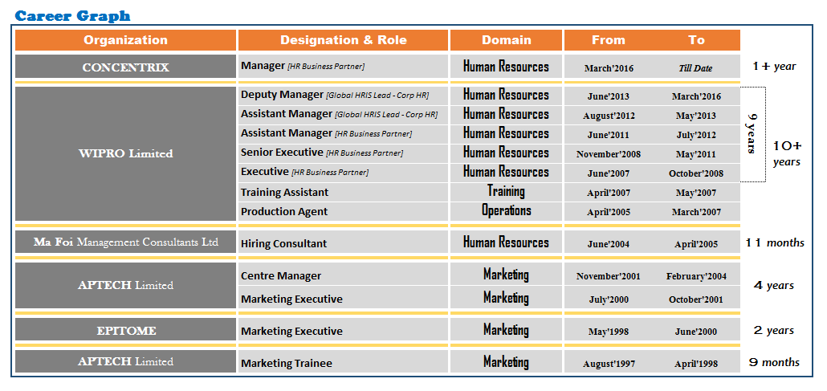

Concentrix, Gurgaon Human Resources March, 2016-till date

Current Designation –Manager
Key Result Areas as HR Business Partner Domain: Employee Relation/ Engagement

- Responsible for driving and maintaining various processes facilitating employee engagement, motivation, communication
- Grievance handling; counseling, establishment and maintenance of communication channels
- Facilitate the creating of a world-class working environment that will attract and retain the highest caliber of people
- Drive and execute HR strategies to support and achieve employee relation activities
- Responsible for all employee communication & grievances management
- Actively benchmark all HR activities and adopt suitable initiatives based on industry trends
- Conduct Employee satisfactions surveys and ensure that it is at expected levels
- Facilitate the driving of organization Culture
- Facilitate (through multiple initiatives) and maintain high morale and teamwork resulting in high, employee satisfaction
- Dealing with issues of employee (in) discipline and maintaining employee relations resulting in fun, filled work place amidst high performance orientation
- Ensure regular communication happens from Top Management in the form of Town Halls and Meetings
- Assist is driving Location level Employee Engagement Events
- Plan and Execute Employee Communication on the floor along with Ops
- Conduct Employee Skips and report out and drive actions to closure
- Assist in Employee related documentation and filing of disciplinary cases with central filing team
- Connect with New Hires and drive Retention in 90 days bracket
- Team Handling / Management

Wipro Limited (BPS Division), New Delhi Human Resources April, 2005-March, 2016

Designation – Deputy Manager
Key Result Areas as GLOBAL HRIS LEAD Domain: Corporate HR August, 2012 till March, 2016

- Liaison with Legal team to gauge legal implications of the Org Policies and Practices and recommend changes if required
- Audit the existing HR Process and Practices
- HRIS Project Management – System Enhancements & HR Automations
- Process Improvement –Gap analysis and Deploy changes basis feedback & analysis
- Design & Conceptualize Mobile Apps for HR processes
- Org Structure Management
- Perform Consulting role for others who undertake automation projects which has linkage to SAP / Org Structure
- Drive System Hygiene (HR System cleanup and creating awareness)
- Rebadging, Merger & Acquisitions and Legal Entity Migrations
- BI Report Automation [Designing Report formats, advising SAP fields and logics to be used, defining Access matrix]
- System Enablement / Technical Assistance for internal/external Surveys
- Technical Support to the HR Team
- Org Communication
- Frontend Audits (internal / External) related Payroll, QMS, etc from System stand point
- Create SOPs & User Manual
- Training (New Launch & Induction)

Key Result Areas as HR Business Partner Domain: Employee Relation/ Engagement June, 2007 till July, 2012

- Excellence in HR Processes- Effective implementation of HR processes
⬇ Appraisal Processes ⬇ MYPP Processes (Employee Engagement)
⬇ Separation Process- Exit, DTS ⬇ Progression and Fulfillment Process
- Retention Initiatives (Focused Group Discussion, One on Ones & Drive Engagement Activities)

- Employee Communication
⬇ Facilitating HR Automation Initiatives - SAP Change Management & Smooth Transition
⬇ Implementation of policies and processes as per defined timeframes
- Developing the Leadership Pipeline – Leadership Feedback, Employee Retention & Drive Engagement Survey
- Performance Management System – Implementation of PMS Project Plan and Adherence to Timelines. Scheduling Awareness Workshop and Driving Coverage (along with PMS Approach Note creation & Sign-off and Bell Curve compliance). Resolving PMS related Employee Grievances and Handling PMS Exceptions
- Completion of investigations (behavioral issues & non-compliance) and report observations with recommended action
- Validation of incentive pay
- Capability Building
⬇ Focused development programs for the team members for developing HR domain knowledge
⬇ Regular Feedback and Review mechanism, monthly formal review for DR's
Achievements :
- 18% reduction in Salary Hold cases – which is directly linked to Employee Satisfaction
- Reduction of Headcount due to automation of Movement process for GEOs – earlier there was a dedicated team who manages this manually (30 FTEs)
- Streamlining of Part Time Employment – which had annual financial leakage above INR 11 lakhs
- Won Wipro Global Excellence Award (June, Year 2014) for handling SAP Org Structure, which had Leadership visibility
- Received Trailblazer Award 2014 for my contribution in streamlining and aligning BPS business with the Parent company
- System Implementation / Automation
⬇ Merit Salary Increase Automation (application for Budgeting & Letter Distribution)
⬇ Launched Employee Movement module for GEOs
⬇ Variable Pay communication
⬇ Employee Data Management
⬇ Auto tagging of Employee Hierarchy, if it gets broken for any reason
⬇ Launched Leave & Attendance module for Domestic Business
⬇ Resignation Module Redesigned to capture relevant feedback
⬇ System implementation of Work From Home
⬇ Simplification of Movement Process
⬇ Tracking productivity for non-billable resources
⬇ System Reports for tracking disciplinary action taken for Unauthorized Absenteeism
⬇ Dynamic Email Distribution List for Org Communication
⬇ System generated Birthday Greetings
- Org Structure Clean-up – a Manual identification of 30,000+ employees and bifurcated them basis Legal Entity, LOBs/Functions, Practice/Sub Function, Account & Location level. Standardization of Organization Structure and nomenclatures
- Surveys (Internal / External)
⬇ Dataquest CMR BPO E-Sat Survey 2012 with 100% participation and ranked 2nd place
⬇ Great Place to Work ⬇ EPS & Pulse
- Audits (Internal/External) – Handled Global Audit twice & PCI DSS 2.0 certification audit conducted by one of Wipro’s client [Pioneer in Printer Industry]
- Prepared template on Attrition Analysis Report, which is appreciated by the internal customer
- Prepared Automated tracking template – reduction in man-hours involved in tracking the deliverables
- Recognition received by internal clients for my contributions & support as their Business HR
Ma Foi Management Consultants Ltd, Guwahati Human Resources June, 2004 – April, 2005

Designation – Hiring Consultant Domain: Sourcing & Recruitment
Key Result Areas

- Sourcing & Screening candidates as per client requirements & scheduling interviews
- Head hunting & profiling people as per the client requirement
- Client Relation

- Organizational Structure Mapping
- Lead generation and sign-ups
- Outsourced Staffing Management & Maintaining the headcount

APTECH Limited, Panbazar, Guwahati Marketing & Administration July, 2000 – February, 2004

Designation – Centre Manager
Key Result Areas

- Monitoring team performance and target setting
- GAP & Up-skill training
- In-house administration (Logistics)
- Handling the corporate training matters
- Facilitating campus interview
- Brand promotion
- Conducting school and college seminars to bring IT awareness among the youth

SCHOLASTICS
- Bachelor of Commerce (B.Com) from Gauhati Commerce College, which is under Gauhati University in the year 2000.
- Higher Secondary Examination (10+2) from Vidya Mandir Jr. College, which is under Assam Higher Secondary Education Council in the year 1997.
- All India Secondary School Examination (10th / Matriculation) from Kendriya Vidyalaya Khanapara, which is under CBSE in the year 1995.
- Higher Diploma in Software Engineering from APTECH Limited, Ulubari, Guwahati.

IT SKILLS: SAP HCM [R/3] & MS Office

PERSONAL DOSSIER
Date of Birth : July 23, 1979
Languages Known : English, Hindi & Assamese
Marital Status : Married

